Name: Om Thanage
Roll No: 16010123217
YEAR: SY
BATCH : C3

_____________________________________________________________________

AIM: Implementation of Disk scheduling algorithms - FCFS, SSTF, SCAN, CSCAN, LOOK, CLOOK (Any two) as instructed by instructor)

______________________________________________________________________
Expected Outcome of Experiment:
CO 4. To understand various Memory, I/O and File management techniques.
___________________________________________________________________
Books/ Journals/ Websites referred:

TITLE: Implementation of Disk scheduling policies
- Silberschatz A., Galvin P., Gagne G. “Operating Systems Principles”, Willey Eight edition.
- Achyut S. Godbole , Atul Kahate “Operating Systems”, McGraw Hill Third Edition.
- Sumitabha Das “ UNIX Concepts & Applications”, McGraw Hill Second Edition.
_____________________________________________________________________
Pre Lab/ Prior Concepts:

The main purpose of disk scheduling algorithm is to select a disk request from the queue of IO requests and decide the schedule when this request will be processed.

Goal of Disk Scheduling Algorithm

FCFS Scheduling Algorithm

It is the simplest Disk Scheduling algorithm. It services the IO requests in the order in which they arrive. There is no starvation in this algorithm, every request is serviced.

SSTF Scheduling Algorithm

Shortest seek time first (SSTF) algorithm selects the disk I/O request which requires the least disk arm movement from its current position regardless of the direction. It reduces the total seek time as compared to FCFS.

It allows the head to move to the closest track in the service queue.

Scan Algorithm

It is also called as Elevator Algorithm. In this algorithm, the disk arm moves into a particular direction till the end, satisfying all the requests coming in its path, and then it turns back and moves in the reverse direction satisfying requests coming in its path.

It works in the way an elevator works, elevator moves in a direction completely till the last floor of that direction and then turns back.

Look Scheduling

It is like SCAN scheduling Algorithm to some extant except the difference that, in this scheduling algorithm, the arm of the disk stops moving inwards (or outwards) when no more request in that direction exists. This algorithm tries to overcome the overhead of SCAN algorithm which forces disk arm to move in one direction till the end regardless of knowing if any request exists in the direction or not.:
___________________________________________________________________
Assigned Algorithm 1 details:

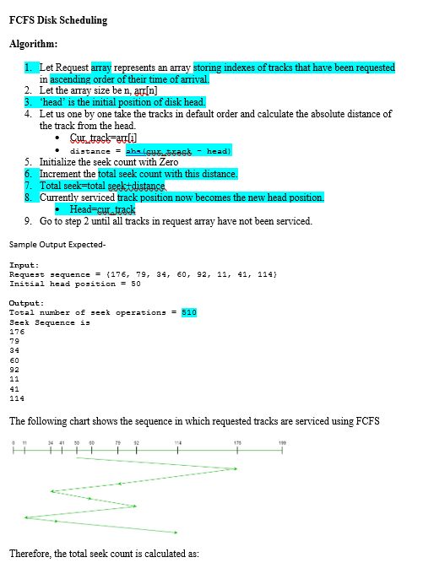
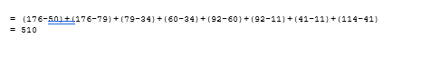
Assigned Algorithm 2 details:
Scan
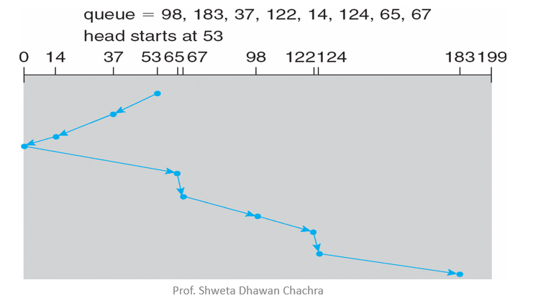


Omik Acharya Assigned:
SSTF
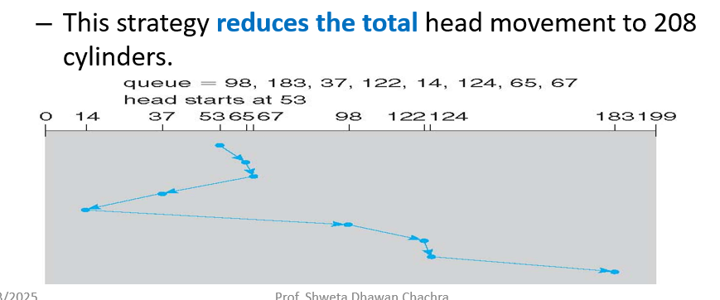
CScan
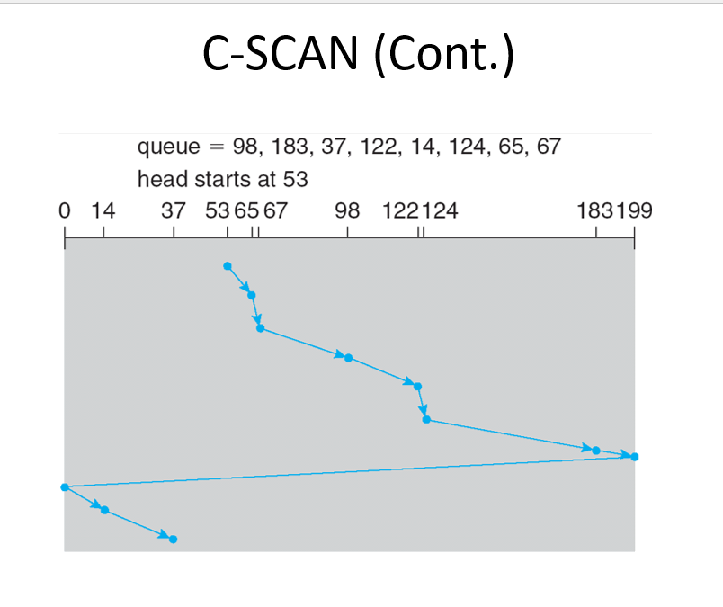
Source code:
FCFS
#include <bits/stdc++.h>
using namespace std;
#define int long long
#define endl "\n"

const int MOD = 1e9 + 7;
const int INF = LLONG_MAX >> 1;

signed main(){
cout<<"Enter the number of elements:\t";
int n; cin>>n;
vector<int> v(n);
cout<<"Enter the elements: "<<endl;
for(int i = 0; i<n; i++){
cin>>v[i];
}
int head, count = 0, dist;
cout<<"Enter the initial position of disk head:\t";
cin>>head;
for(int i = 0; i<n; i++){
int curr = v[i];
dist = abs(curr-head);
count += dist;
head = curr;
}
cout<<"Total number of seek operations = "<<count<<endl;
cout<<"Seek Sequence is:"<<endl;
for(int i = 0; i<n; i++) cout<<v[i]<<endl;

return 0;
}

SCAN
#include <bits/stdc++.h>
using namespace std;
#define int long long
#define endl "\n"

const int MOD = 1e9 + 7;
const int INF = LLONG_MAX >> 1;

signed main(){
cout << "Enter the number of elements:\t";
int n; cin>>n;

vector<int> v(n);
vector<int> lower, upper;

cout<<"Enter the elements:\n";
for(int i = 0; i < n; i++){
cin>>v[i];
}

cout<<"Enter the initial position of disk head:\t";
int head, count = 0; cin>>head;

cout<<"Enter the side to scan (Enter L for low track or Enter R for higher track) \t";
char direction; cin>>direction;

for(int i = 0; i < n; i++){
if (v[i] < head)
lower.push_back(v[i]);
else
upper.push_back(v[i]);
}

sort(lower.rbegin(), lower.rend());
sort(upper.begin(), upper.end());

cout<<"Seek Sequence is:\n";

if (direction == 'L') {
for(int curr : lower){
cout << curr << " ";
count += abs(head - curr);
head = curr;
}
for(int curr : upper){
cout << curr << " ";
count += abs(head - curr);
head = curr;
}
}
else if (direction == 'R') {
for(int curr : upper){
cout << curr << " ";
count += abs(head - curr);
head = curr;
}
for(int curr : lower){
cout << curr << " ";
count += abs(head - curr);
head = curr;
}
}
else {
cout<<"Invalid direction! Please enter 'L' or 'R'.";
return 0;
}

cout<<"\nTotal number of seek operations = "<<count<<endl;
return 0;
}

Partner Assigned Programs: (Omik Acharya)
SSTF
#include <bits/stdc++.h>

using namespace std;

int main(){
cout << "Enter the number of requests: ";
int n; cin >> n;
cout << "Enter the head: ";
int head; cin >> head;
vector<int> arr(n);
for(auto &i: arr) cin >> i;

auto getCurr = [&](int prev){
auto comp = [&](int i, int j) -> bool{
return abs(i - prev) < abs(j - prev);
};
sort(arr.rbegin(), arr.rend(), comp);
int fin = arr.back();
arr.pop_back();
return fin;
};

int prev = head;
int totalSeek = 0;
cout << head << ' ';
for(int i=0; i<n; i++){
int curr = getCurr(prev);
totalSeek += abs(curr - prev);
prev = curr;
cout << curr << ' ';
}

cout << "Total Seek Time: " << totalSeek << '\n';
return 0;
}

CSCAN
#include <bits/stdc++.h>

using namespace std;

int main(){
cout << "Enter the number of requests: ";
int n; cin >> n;
cout << "Enter the head: ";
int head; cin >> head;
cout << "Enter the direction ('L' OR 'R'):";
string dir; cin >> dir;
vector<int> arr(n);
for(auto &i: arr) cin >> i;

if(dir == "L"){
arr.push_back(head);
sort(arr.rbegin(), arr.rend());
int ind = find(arr.begin(), arr.end(), head) - arr.begin();
rotate(arr.begin(), arr.begin() + ind, arr.end());
}
else if(dir == "R"){
arr.push_back(head);
sort(arr.begin(), arr.end());
int ind = find(arr.begin(), arr.end(), head) - arr.begin();
rotate(arr.begin(), arr.begin() + ind, arr.end());
}
else{
cout << "Invalid direction: ";
}
cout << "\n\nRequest Sequence:\n";
int prev = head, totalSeek = 0;
for(auto &i: arr){
totalSeek += abs(i - prev);
prev = i;
cout << i << ' ';
}

cout << "\nTotal Seek Time: " << totalSeek << '\n';
return 0;
}

Output screenshots:
FCFS
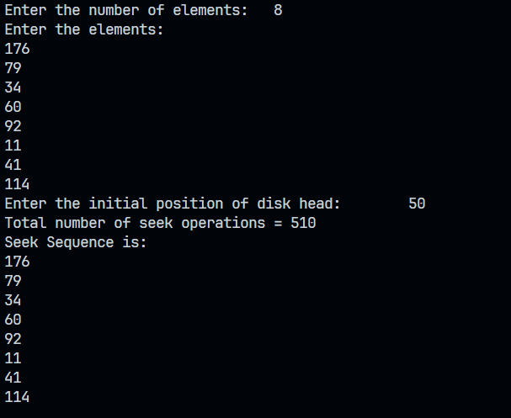

SCAN
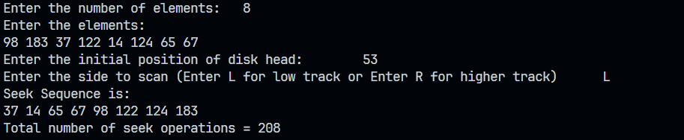

Omik Acharya Assigned
SSTF
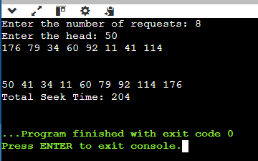
Cscan
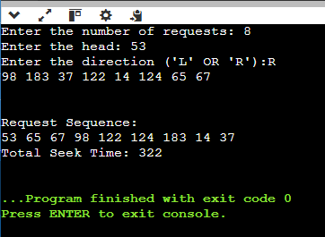
Conclusion:
By doing this experiment we learnt about FCFS, SSTF, SCAN and CSAN algorithms and had a detailed overview on their results

Post Lab Descriptive Questions

- Explain how SSTF can lead to starvation. Can this problem occur in SCAN or LOOK? Justify your answer.
Ans. Shortest Seek Time First (SSTF) can lead to starvation because it always selects the request closest to the current head position. This means that if new requests keep arriving closer to the current position, requests that are far away may never get serviced.
For SCAN and LOOK, this problem does not occur. The reason is that these algorithms move the disk arm in one direction until they reach the end (SCAN) or the last request (LOOK), ensuring that all requests are eventually served. Thus, starvation is avoided in SCAN and LOOK.

- How does the size of the disk (number of tracks) influence the performance of the SCAN, C-SCAN, and LOOK algorithms? Provide examples to support your answer.
Ans. the size of the disk (number of tracks) affects the performance of SCAN, C-SCAN, and LOOK in the following ways:
- SCAN:
  - As the number of tracks increases, the seek time also increases because the disk head must travel a larger distance.
  - If there are many requests spread across the disk, SCAN ensures that all are serviced in a fair manner.
  - Example: If a disk has 200 tracks and requests are at 10, 50, and 180, SCAN will serve them efficiently. But if the disk has 1000 tracks, the head may take longer to reach far requests.
- C-SCAN (Circular SCAN):
  - Since C-SCAN only moves in one direction and jumps back to the beginning, its performance depends on the number of tracks.
  - A larger disk size means longer jumps when reaching the highest track, which increases seek time.
  - Example: On a 500-track disk, jumping from 499 to 0 is faster than on a 2000-track disk, where the jump from 1999 to 0 takes more time.
- LOOK:
  - LOOK reduces unnecessary movement compared to SCAN by stopping at the last request instead of going to the last track.
  - On larger disks, LOOK is more efficient than SCAN because it avoids moving all the way to the edges if there are no requests there.
  - Example: If requests are at 50, 100, and 400 on a 500-track disk, LOOK stops at 400 instead of going to 499, saving time.

- Suppose that a disk drive has 200 cylinders numbered 0 to 199. Consider a disk queue with I/O requests on the following cylinders in their arriving order: 54, 95, 73, 130, 25, 48, 110, 30, 45, 180, and 190. The disk head is assumed to be at cylinder 24. Starting from the current head position, what is the total distance (in cylinders) the disk arm moves to satisfy all the pending requests for the SCAN and LOOK disk-scheduling algorithm?

Ans. 1. SCAN Algorithm (Elevator Algorithm)
- The disk arm moves right, serving requests in ascending order.
- It reaches the end of the disk (199) before reversing.
Movement sequence:
- Move right: 25 -> 30 -> 45 -> 48 -> 54 -> 73 -> 95 -> 110 -> 130 -> 180 -> 190
- Continue to 199 (end of disk)
- Reverse direction (not needed since all requests are served).
Total movement:
- First segment: 199−24=175199 - 24 = 175
- 199−24=175 cylinders
- Total: 175 cylinders

2. LOOK Algorithm (Optimized SCAN)
- LOOK stops at the last request (190) instead of going to 199.
Movement sequence:
- Move right: 25 → 30 → 45 → 48 → 54 → 73 → 95 → 110 → 130 → 180 → 190
Total movement:
- First segment: 190−24=166190 - 24 = 166
- 190−24=166 cylinders
- Total: 166 cylinders
Answer:
SCAN Total Distance: 175 cylinders
LOOK Total Distance: 166 cylinders

Date: 27/03/25

